The Harrison-Norvill Cemetery:
An Abandoned Part of Prince William County’s Rich History
By Raymond Vance Olszewski
~
“Here rests our Father until the morning of resurrection”
“Made perfect through suffering, asleep in Jesus”
“His Earthly Remains Lie Here”
“My grave is sufficient for thee”
~
Introduction
An epitaph such as those four quoted above can still be found engraved on the deteriorating gravestones that mark where the remains of at least eleven Prince William County citizens are buried. The words used in an epitaph are often chosen and written by someone other than the deceased offering an everlasting tribute to the individual’s life. When the epitaph becomes coupled with the individual’s name, date of birth, date of death and other identifying information about them on the headstone becomes a memorial to their lives and usually marks where their remains are buried.
In 1997, the Prince William County Historical Commission initiated a project to locate, survey, and record all of the County’s cemeteries to update the County’s Cultural Resource Plan (CRP). The project took several years and over 400 cemeteries were found and documented by volunteers who painstakingly conducted the surveys and recorded valuable and useful historic information. A list of these cemeteries and who are buried in them is published by local county historian Ronald Ray Turner on his website at www.pwcvabooks.com. The County used the data collected from these surveys to update the County’s Cultural Resource Map which lists over fifty “High Sensitive Areas and County Registered Historic Sites.”
One of the historic sites listed in the County’s CRP is the La Grange property located in the western part of the County on Antioch Road, near Haymarket, Virginia. Research into its history reveals that La Grange is, in fact, very historic; however, little has been published about it. Today, the County’s first Virginia farm winery, the Winery at La Grange, operates at this historic site. The land on which the winery is located was once part of an original 300 acres located next to the northern part of Robert “King” Carter’s vast Bull Run and Broad Run Tracts that was first deeded by Lord Fairfax to William Watkins in 1741. Since that time, the ownership and size of the property has changed several times and research into its past has found a unique history of this site. Up until the early 1900s, the La Grange farm estate produced a comfortable and elegant lifestyle for its inhabitants, who lived, laughed, loved, and played on the premises; the remains of some of those who lived then are buried in the Harrison-Norvill Cemetery.
Today, visitors to the Winery at La Grange are fortunate in that they can still experience the rich past the property has to offer. These experiences can be found in two unique and distinct remaining historic structures that have withstood the test of time. They include a two and a half story red-brick manor house built ca 1790 and an adjacent Spring House which has the date of April 12, 1800 with the initials, ‘W*L’ scratched into its cornerstone. There is yet a third historical part of La Grange’s rich past that has not been well-recognized. It is the “Harrison-Norvill” Cemetery that is located in the backyard of a private residence in the nearby upscale Thunder Oak Community. Here is where the remains of those who were related to Benoni Evans Harrison, the owner of La Grange from 1827 until he died in 1869 are buried along with him. These citizens lived their lives and made their livelihood in the county during the 18th and 19th centuries.
In 1997, two local historians, Ronald Ray Turner and Betty Duley, were the last to have conducted a formal survey of the Harrison-Norvill Cemetery. Previously, there were four other surveys conducted by different people for different reasons. Like the others, Turner and Duley recorded the names, dates of death, places of birth, and other vital information they found engraved in the tombstones. The four epitaphs shown above the introduction to this article were recorded by the survey team directly from the tombstones of family members having the surnames of Harrison, Norvill, Jordan, White, and Gossom. One interesting observation Turner and Duley made was that they designated the cemetery as being “abandoned.” Ron Turner, who publishes a vast amount of historical information about the county’s past on his website, is credited with the axiom “History not shared is History Lost!” In his introductory remarks, Turner states that he hopes that future generations would build on the valuable work that he and others accomplished for the County’s 2001 Historical Commission Report.
This reliquary article does just that – builds upon that which has been found by the author and begins to present the findings in a series of articles that have resulted from the extensive research into the history of the La Grange property and its owners. This first article focuses on the Harrison-Norvill Cemetery, which describes its origin, and identifies those souls who are buried in it. It also brings attention to the diminishing and deteriorating condition of this abandoned cemetery with hope that its poor state will be corrected.
Harrison-Norvill Cemetery Origin
In 1869, Harrison bequeathed in his Last Will and Testament that a half-an-acre of the La Grange land be set aside as a revered place where his remains and those of other relations would be buried and memorialized. In the opening section of his last will and testament dated January 21, 1869 found at the County’s Court Archives, Harrison wrote:
“First I give and Bequeath to all who are in existence at the time of my death half an acre of the three hundred and eighty eight acres of land I possess called Lagrange for a Grave Yard forever for the family of myself and Captain Peyton Norvill in which he is deposited and his second wife and several of his children amongst them my dear wife who was his first daughter. Of Course I mean of my own and Peyton Norvills Blood Relation…”
The location of the Harrison-Norvill Cemetery is on a piece of land that was once part of the vast farm estate owned by Benoni E. Harrison which he had purchased in 1827 and retained it until he died in 1869. Today, the land where the cemetery is located was absorbed into the upscale Thunder Oak Community development sometime in late 1990s, early 2000.
It is interesting to note that all the Norvill family members that Benoni Harrison mentions were already dead and buried when he wrote his will in 1869. The first to die and be buried in the cemetery was his father-in-law Peyton Norvill, who passed away on June 13, 1849. The next Norvill buried at this cemetery was Peyton Norvill’s second wife, Sarah Ann nee Reid, who died on December 1, 1854. The third and fourth Norvill family members to be buried in the cemetery were two of three daughters born to Peyton Norvill and his first wife, Mary (1780-1820). The two sisters were Margaret, who died on February 14, 1864 and Catherine, who was married to Benoni E. Harrison, and according to county records died from paralysis on March 26, 1865.
A History of Surveys
Between 1937 and 1997, a total of five surveys were found to have been conducted on the Harrison-Norvill Cemetery. Like the Turner/Duley survey, these surveys captured vital information about those buried at the cemetery as well as other historical and revealing previously unknown information. The results of these five surveys are presented in this article along with author’s own conclusions and observations about what was found.

Survey #1: 1937 Harrison-Norvill Cemetery Survey by Susan Rogers Morton
This first known survey of the Harrison-Norvill Cemetery was conducted by Ms. Susan Rogers Morton of Haymarket, Virginia in 1937. Ms. Morton’s efforts were part of a Works Progress Administration (WPA) program that began in the Depression Era (1935). The Library of Virginia in Richmond, VA now owns the records Ms. Morton created during her work for the WPA project. According to the authors of a compilation of her records, Morton is credited with as many as 30 cemetery and property surveys.
The La Grange survey which Ms. Morton conducted appears to have been more focused on the La Grange manor house and its surrounding area. Her records also reflect the existence of multiple cemeteries on the property. She wrote about these cemeteries as follows: “There are two graveyards on the place, one of considerable size by the side of mountain road, but no inscriptions.” Morton then added further that she found inscriptions on tombstones in a second cemetery “…some distance from the house, to the southwest, not very far from the Antioch Road:” Morton lists the inscriptions she found on four tombstones as follows, but adds after listing them “There are numerous other stones and some more inscriptions, but too defaced to make them out.”
- “In memory of Peyton Norville, who died at Brentsville, Virginia, June 17th, 1849 in the 70th year of his age.
- Sarah Norville died 1854. Made perfect through suffering.
- Sacred to Benoni Harrison, born in Prince Wm. County, Virginia January 17th, 1804, died August, 1888 (Masonic emblem) His earthly remains in here. Benoni Harrison, born 1767.
- Sacred to the memory of Margaret Norville, sister of Catherine Harrison. She died on the 14th of February, 1864 in the 67th year of her age.”
Conclusions/Observations:
- Morton identifies the date of death for Peyton Norvill as June 17th while subsequent surveys record his date of death as June 13.
- Morton missed additional information found in later surveys about Sarah Norvill (See Survey #4).
- A later survey (Survey #4) found the inscription “Here rests our Father until the morning of resurrection” on Peyton Norvill’s tombstone which Ms. Morton does not mention.
- The “mountain road” cemetery Ms. Morton refers to is an unknown.
- The cemetery Ms. Morton refers to being “some distance from the house…” is believed to be that which today is called the “Harrison-Norvill Cemetery” located in the backyard of the Thunder Oak Community resident.
- Missing from Ms. Morton’s survey is a gravestone for Benoni’s wife, Catherine, who died in 1865. Subsequent surveys reflect that a gravestone for Catherine did exist. Perhaps, Catherine’s gravestone was one of those who Ms. Morton noted to have been “…too defaced to make them out.”
- Dates that Ms. Morton or the compilers published from her records found at the Library of Virginia are in error; the dates for Harrison’s birth years (1804 and 1767) and death year (1888) are incorrect. As corroborated from other sources, the birth year for Benoni E. Harrison is 1786 and 1869 for his year of death.
- There is some contention if Benoni E. Harrison was actually born in Prince William County. To date, no evidence has been found to support his own declaration that he was in fact a “Native of Prince William County, born on January 17th, 1786.” There is an ongoing effort to establish where and when Benoni Evans Harrison and his twin sister, Mary were born and who their parents were.
- The first cemetery that Ms. Morton identifies being located by the “Mountain Road” may, in fact, be an unidentified and yet an undocumented slave cemetery.
- There is no mention by Ms. Morton of a tombstone or a grave for Hugh Watkins White (1839-1912) who according to family records was buried at La Grange when he died in 1912. White was the husband of Harrison’s grandniece, Betty Jane Jordan who is actually buried elsewhere.
- There is a variant in the spelling of the name of Norvill by Ms. Morton. The author notes that this family name has been spelled a number of different ways, sometimes with an “e” and without an “e.” Using Peyton Norvill’s last will and testament and information from other surveys, the transcription reflects “Norvill” as the correct family surname spelling.
- Ms. Morton did not provide a specific location for the cemetery other than being located to the southwest near Antioch Road. Later surveys by W. Brown Morton III (Survey #3) and E.R. Conner III (Survey #4) reported that a consolidation of the tombstones from other locations had occurred at unknown times.
Survey #2: 1952 - Harrison-Norvill Cemetery Survey by Mrs. Christine Russell Drowne Hathaway
In 1952 during a visit from her home in Rhode Island to Virginia, Ms. Hathaway who was a descendant of Hugh Watkins White recorded the following tombstone inscriptions she found at the cemetery:
- Sacred to Catherine, the devoted wife of B.E. Harrison of Prince Wm C’ty, Va. upwards of 44 years. She died on the 26th of March, 1865 in the 61st year of her age.
- Sacred to Margaret T. Norvill the sister of Catherine Harrison. She died on the 14th of Feb’y, 1864, in the 57th year of her age. Footstone: MTN.
- Sacred to Mary M. Jordan, the twinn sister of B.E. Harrison of Prince Wm. C’ty, Va. She died on the 12th of Feb’y, 1861, in the 75th year of her age. Footstone MMJ (Note: the word ‘twinn’ is spelled as it was engraved.)
- Sacred to the memory of Sarah A. Norvill Died Dec. 1, 1854 in the 66th year of her age. “Made perfect through suffering” “Asleep in Jesus”
- In memory of Peyton Norvill who departed this life at Brentsville Va., June the 13th, 1849 in the 70th year of his age. Here rests our father until the morning of the resurection(sic).
- In memoriam B.H. Jordan Born Oct. 8, 1820, Died Jan 7, 1894 My grace is sufficient for thee.
- SACRED TO (Masonic Emblem) BENONI E. HARRISON, Born in Prince William C’ty., Va., Jan 7, 1786, Died August 17, 1869 in the 84th year of his age. His earthly remains lie here. Footstone BEH
- Mary H. Daughter of H.W. & E.J. White Born Aug. 8, 1874 Died May 7, 1876
Conclusion/Observations:
- Of note is that Ms. Hathaway recorded there were three grave foot stones adding to the Cemetery’s marker inventory. Today, only one footstone engraved “MTN” for Margaret T. Norvill can be found.
- A tombstone for Catherine, Benoni’s wife, is present in Hathaway’s recordings.
- Differences in Benoni Harrison Jordan’s tombstone inscription were found. Two surveys state “grace” and one states “grave.” Hathaway (Survey #2) and Turner/Duley (Survey #5) uses grace and Conner (Survey #4) uses grave. Without a physical confirmation by this author, it is believed the correct word in the epitaph is “grace.”
- Ms. Hathaway also did not include the marker for the graves of John C. Gossom (1838-1899) and his wife, Mary F. Gossom (1838-1925). The Gossoms are buried just a few yards to the north from the Harrison, Norvill, Jordan, and White tombstones found at the cemetery. It is possible the Gossom graves were there but the tombstone perhaps was not in 1952.
- Ms. Hathaway does not identify as to where the cemetery is specifically located nor provides any information about the cemetery’s overall condition.
- Ms. Hathaway does not list or mention the existence of a tombstone or grave marker for her grandfather, Hugh Watkins White, who is, according to family records, also buried there.

Survey #3: 1959 - Harrison-Norvill Cemetery Survey by W. Brown Morton, III
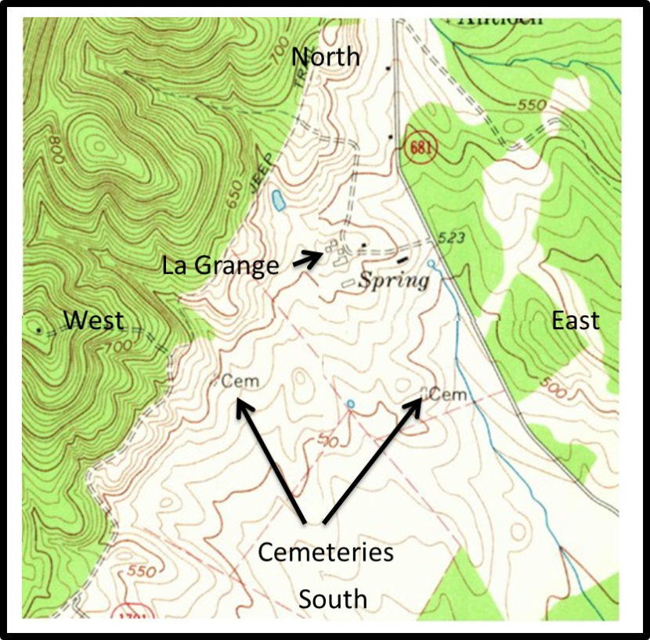
As a project for the Virginia Historic Landmarks Commission (VHLC), W. Brown Morton III (no known relation to Susan Rogers Morton) also conducted a survey of the La Grange property. His report just states that “Benoni Harrison and others are buried in the cemetery at LaGrange.” He adds further: “This cemetery, a short-distance west of the house and near the barn, contains about 10 markers recently moved from the two cemeteries marked on the U.S.G.S. (United States Geological Service) map.” He also noted: “The cemetery contains markers for Harrisons, Norvilles, Gossoms, Whites and Jordans.” Morton did not provide any tombstone inscription information in his report to the VHLC.
Conclusion/Observations:
- The particular USGS map that Mr. Morton is referring to is shown at Figure 1. It is annotated with the word “spring” once, and the abbreviation “cem” twice. “Cem” is a commonly used abbreviation for “cemetery” found on USGS maps. On the map there is one “cem” annotation located to the southwest of the La Grange manor house and the other to the south; the latter “cem” marking is believed to be that representing the Harrison-Norvill Cemetery. The other cemetery Morton refers to as being “to the southwest” is a mystery and may also be the same cemetery that Susan Rogers Morton (Survey #1) located and identified to be near the mountain road.
- Morton makes an observation that “10 markers recently moved…“ This is the first reference found in the surveys about cemetery tombstones (markers) being moved.
Figure 1. USGS Map Showing La Grange, spring, cemeteries.
- Morton’s report suggests that another cemetery did exist at one time on the La Grange property. Both of the Morton surveys (#1 and #3) refer to the existence of a cemetery near the Barn on the La Grange property. (Note: a large barn existed in 2005 that located about 200-300 yards northwest of the manor house, which has been torn down.)

Survey #4: 1980 - Harrison-Norvill Cemetery Survey by E.R. Conner
In 1980, E.R. Conner, III, a local County historian and author of 100 Old Cemeteries of Prince William County, Virginia (1981), concluded from his survey activity that “All Harrison and Norvill markers appear to have been disturbed from original locations and are in deteriorated condition.” Conner described where the cemetery was located as “At La Grange Farm, west of Antioch Rd., (Rte. 681), 0.5 mi. south of intersection with Waterfall Rd. (Rte. 601). Cem. is in grove on hill in field 0.2 mi. south of main house.” His handwritten notes also reflect that “Harrison tombstones, Norville, etc. now in w/Gossoms.” He added that the “Harrisons were moved from south of house.” Another note made by Conner reflects that “Other Norvills disappeared” and then in his notes lists a total of nine names as follows: “2 Norvill, 2 Harr [Harrison], 2 Gossoms, 1 B.F. Jordan, and 2 Whites.”
Conner listed the following inscriptions:
- SACRED/to the memory of /SARAH A. NORVILL/Died Dec 1, 1854/in the 66th year of her age/Made perfect through suffering.
- SACRED/to the memory of/MARGARET NORVILL/the sister of/Catherine Harrison/Who died on the 14th of Feb’y 1864, in the/57th year of her/age. (broken)
- In/memory of/PEYTON NORVILL/who departed this life/at Brentsville, Va./June 13th 1849/in the 70th year of his age/Here rests our father/until the morning of/the resurrection.
- SACRED/to the memory of/BENONI E. HARRISON/______/His earthly remains lie here./Born in Prince William Co. (broken; remainder illegible)
- In memoriam/B.H. JORDAN/Born Oct 8, 1820/Died Jan 7, 1891/My grave is sufficient for thee.
- WHITE/MARY H./Daughter of/H.W. & E.G. White/Born Aug 8, 1874(?)/Died May 7, 1876
- GOSSOM/JOHN C./NOV 2, 1838/MAY 17, 1899/MARY F. HIS WIFE/JUNE 9, 1838/AUG 17, 1925 Note: Conner adds that the Gossom stone was enclosed by a board fence.
Conner obviously knew about the legendary “spanking” story which Susan Rogers Morton had also mentioned in her notes and included in the WPA compilation. What Conner was referring to had to do with the absence of a tombstone for Catherine stating in his book: “Whether or not this was his [Harrison’s] intention, no marker to Catherine Norvill Harrison is visible at La Grange today.” Conner explains further adding: “The ambiguous placement of the phrase [in the will], ‘will not contain the inscription’ has led some local historians to conclude that Harrison directed that his wife’s stone bear no inscription. Whether or not this was his intention, no marker to Catherine Norvill Harrison is visible at La Grange today.”
The phrase “will not contain the inscription” Conner is referring to can be found in a paragraph of Harrison’s first of two recorded wills found in Will Book R at the County’s Clerk’s first.
“I will that a marble slab or head stone sufficiently large to have carved on the following inscription in large letters of the size of that procured by me for my dear departed wife will not contain the inscription a marble slab four inches thick and a long and wide enough to cover my grave be procured and in the inscription carved on it and it carefully and substantially placed over my grave.”
Conner’s survey activity extends further to identifying the existence of slave cemeteries on the La Grange property. This information was brought to light in an interview he had with a descendant of Benoni E. Harrison by the name of David Garrett, a great-great nephew. Conner writes in his notes: “…a small cem. believed to have been used by slaves was visible in the 1930’s northwest of the main house near the ruins of the old slave quarters.” Conner continues in his notes that Garrett also told him: “Fieldstones here were unmarked.”
Additional information about grave sites on the property was further found in Conner’s notes from another interview he had with a George Pearson, who reportedly was once an employee on the farm in the late 1940s. Pearson told Conner: “…two additional grave sites were found about that time. Near the north edge of the farm, one grave was discovered by workers building a fence when a posthole-digging tool sank into the ground.” Pearson further informed Conner: “…on the south end of the farm, an unmarked gravestone was plowed up at what was believed to have been the burial place of a slave.”
Conclusions/Observations:
- No mention is made of a grave or marker for Hugh Watkins White (1839-1912). White was the husband of Harrison’s grandniece, Elizabeth “Betty” Jane Jordan.
- Conner recorded Mary Hope White’s information as “Daughter of H.W. and E.G. White” which is incorrect and should be “E.J. White.”
- No mention of a tombstone by Conner for Mary FM. Jordan, Benoni’s twin sister. She was found to have a marker by Turner/Duley (Survey #5).
- Two different spellings of the surname Norvill by Conner was used in his report.
- This is the second reference found about the existence of slave quarters and the existence of another cemetery on the La Grange property.
- If the cemetery had been disturbed as observed by Connor is true, this would have had to happen between the time that W.B. Morton III (Survey #3) conducted his survey in 1959, and Conner (Survey #4) conducted his survey in 1980.
- The place where the Harrison-Norville Cemetery is located today is much farther than the distance of the 0.2 mi. south of main house which Conner’s notes reveal. As the crow flies the cemetery’s distance is at a distance of 0.4 mile from the La Grange Manor House. Also, when measured by an odometer traveling on Antioch Road from La Grange to the intersections of Lightning and Thunder Roads, the cemetery’s distance is 0.5 of a mile. If one uses Connor’s calculations of 0.2 of a mile, the cemetery would be located in the neighbor’s yard located directly south next to the La Grange Winery property.
- It is not certain why Conner omitted or missed Catherine’s grave stone.

Survey 5: 1997 - Harrison-Norvill Survey by Ron Turner and Betty Duley for the PWC Historical Commission
As previously mentioned earlier in this article, the duo of local historians, Ron Turner and Betty Duley, surveyed the cemetery in 1997 for the County’s Historical Commission. Their survey listed the following tombstone inscriptions:
- Stone #1: Sacred to the memory of Margaret Norvill the sister of Catherine Harrison, she died on the 14th of Feb’r 1864 in the 57th year of her age (tombstone broken) footstone M.T.N.
- Stone #2: Sacred to the memory of Sarah A. Norvill, died Dec 1 1854 in the 66th year of her age, “made perfect through suffering, asleep in Jesus”
- Stone #3: Sacred to Catherine the devoted wife of B.E. Harrison of Prince William County VA upwards of ___ years, she died 26 March 1865 in the 61st year of her age.
- Stone #4: Sacred to Benoni E. Harrison born Prince William County, Jan 7 1786, “His Earthly Remains Lie Here”, footstone B.E.H.
- Stone #5: In memory of B.H. Jordan, born Oct 8 1820, died Jan 76 1891, “My grave is sufficient for thee”
- Stone #6: John C. Gossom born Nov 2 1838, died May 17 1899, Mary F. his wife born June 9 1838, died Aug 17 1925
- Stone #7: Sacred to Mary M. Jordan the twin sister of B.E. Harrison of Prince William County VA, she died on the 12th of Feb’y 1861 in the 75th year of her age
- Stone #8: In memory of Peyton Norvill who departed this life at Brentsville Va. June 12 1849 in the 70th year of his age. “Here rest our Father until the morning of resurrection”
- Stone #9: Mary H. White daughter of H.W. and E.J. White, born August 8, 1874?, died May 7, 1876 (stone #9 information found in E.R. Conner’s book One Hundred Old Cemeteries.
The team concluded that there was no reason to do a grid of this cemetery because “most, if not all of the tombstones appear to have been moved.”
Conclusions/Observations:
- The Turner/Duley team is the third reference that a consolidation of the tombstones or that they were moved from other places. The others who made this observation were W. Brown Morton III (Survey 3) and E.R. Conner, III (Survey 4).
- The Turner/Duley team recorded geographical coordinates for the cemetery as “N38 50.829 W077.41.120.” The author also recorded coordinates of the cemetery standing in the middle of the 100’ x 75’ cemetery as: 38° 50’49.71”N 77° 41’ 07.05”W.
- No tombstone or marker for Hugh Watkins White was noted by this survey either.

Stories and Such…
Harrison not wanting his wife’s stone to have an inscription seems to have originated from a legendary and colorful story that caused Harrison to construct a matching fireplace at the La Grange manor house so that he would not have to share the same hearth with his wife. This story continues to be referred to by historians as the “Spanking Story” without any conclusive evidence that it actually happened.
A variant of the Spanking Story is that the incident was supposedly carried out during a birthday party held in Catherine’s honor at the La Grange residence. It seems that Catherine overheard her husband make a disparaging and sexist remark about his wife being a “buxom lass.” In response, Catherine apparently approached Harrison, who was reported by Susan Rogers Morton to be small in stature and, as the story is told, she supposedly picked him up and carried him to the parlor sofa where she turned him over her knee and spanked him.
As a result of this incident, the demise of their relationship began starting with Harrison’s addition of another chimney in the dining room of the manor house. The absence of Catherine’s name in Harrison’s will also suggests further that this anger he had for her continued until well after Catherine’s death and at least up to Harrison’s own death in 1869. A review of Harrison’s will shows he refers to her as: (1) “my dear departed wife”; (2) “my dear wife who was his first daughter;” (3) “…two portraits of my Dear departed wife and myself;” and, (4) “the clothes of my dear departed wife that are found in my dwelling…”.
One unconfirmed source alludes that Benoni Harrison may have had his “slab” inscribed well before he died and perhaps even done when his wife, Catherine, was still living. The source was Richard Benoni Gossom (1873-1959) who published a colorful rendering of the Gossom family’s history some time before he himself passed away. In the document Dick Gossom produced there is a creative and comical draft of a letter that Catherine purportedly wrote to her mother regarding the legendary “spanking incident” which the Harrison’s of La Grange are known well for. In that same letter, Catherine also wrote to her “Momma” that Benoni “…keeps a tombstone already inscribed propped up against a tree in preparation for his death?!” The letter further tells her Momma “…when I die, I’m not going to even get a tombstone.” It is the belief of this author that the contentious marriage between Benoni and Catherine followed them to their graves.
The notion about Harrison’s tombstone being already carved and propped against a tree is corroborated by another source, E.R. Conner III, who conducted Survey #4 and who wrote: “Legend also has it that Benoni Harrison kept his own headstone propped against a tree in anticipation of his death.” E.R. Conner who also surveyed the cemetery in 1980 explaining: “Again, this cannot be verified, but Harrison would seem at the least to have been meticulous in funerary matters.”
An observation made by the author during his visits to the cemetery in 2006, 2011, and 2013 is that all the tombstones for those who preceded Harrison are facing in a westerly direction. Harrison’s tombstone is facing east. Of note is that the tombstone for John and Mary Gossom is also facing east and the marker for Hugh Watkins White that was added sometime between 2008 and 2009 was purposely placed facing east. Those who are in the business of graves or funerary matters, and in the interment of people’s remains say that if the grave markers are facing west, the bodies are facing to the east? Some suggest further that East=Life while West=Death based on the idea that the sun rises in the East and sets in the West. One person added that since Jesus Christ was born in the east the tombstones should be faced in that direction. The condition of the whole cemetery is so bad there is no way to tell without a scientific examination as to how the bodies that are supposedly buried in it are actually oriented.
Summary
Using the Tables 1 and 2 below, there are a total of eleven remains supposedly buried at the Harrison-Norvill Cemetery. With the exception of the Gossoms and Norvills, everyone else is a “blood” relative of Benoni E. Harrison through his twin sister, Mary, who married James Jordon. Note the spelling of the name “Jordon” as Mary married a James Jordon (with an “o”). Other spellings found include Jourdain. Benoni and his wife, Catherine did not have any children nor is there evidence that they adopted any children during their marriage of 44 years. There has always been a total of ten tombstones/markers and three footstones found by those who surveyed the cemetery.
Table 1 List of those Interred prior to and including Benoni Harrison’s death in 1869
Date of Death | Name of Individual  (Date of Birth) | Age at Death | Marker  Present | Footstone  Found | Relationship to  Benoni E.Harrison
13 June 1849 | Peyton Norvill (Born: ~1779) | 70 | Yes | No | Father-in-Law
1 December 1854 | Sarah Ann Reid Norvill (Born: 1791) | 66 | Yes | No | Mother-in-Law
26 March 1865 | Catherine Norvill Harrison (Born: 1804) | 61 | Yes | No | Wife
12 Feb 1861 | Mary M. Jordon (Born: 1786) | 75 | Yes | MMJ | Twin Sister of Benoni E. Harrison
14 February 1864 | Margaret T. Norvill (Born: 1807) | 57 | Yes | M.T.N | Sister-in-Law
17 August 1869 | Benoni Evans Harrison (Born: 1786) | 84 | Yes | B.E.H | Self

Table 2. List of those interred after Benoni Harrison’s death in 1869.
Date of Death | Name of Individual (Date of Birth) | Age at Death | Marker  Present | Footstone  Found | Relationship to  Benoni E.Harrison
8 August 1876 | Mary Hope White (Born: 1874) | 1 year 8 mos 22 days | Yes |  | Great Grand Niece
7 January 1894 | Benoni Harrison Jordan (Born: 1820) | 73 | Yes |  | Nephew
17 May 1899 | John Cornelius Gossom (Born: 1838) | 62 | Yes |  | No Relation (See note 1)
25 July 1912 | Hugh Watkins White (Born: 1839) | 73 | No |  | Husband of Grand Niece
17 August 1925 | Mary F. Gossom (Born: 1838) | 87 | Yes |  | No Relation (See note 1)

Analysis of the information contained in the surveys uncovered a number of anomalies as well as providing additional unknown historical information.
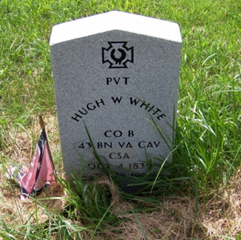
- No grave marker was reported by any of the surveys for Hugh Watkins White who according to family and county records states he was buried at “La Grange.” Between 2008 and 2009 the tombstone shown in Figure 2 was placed at the cemetery in a memorial ceremony that included a ceremonial honor guard arranged by a descendant, Wallace Joseph Harding through the Sons of the Confederacy. White served as a Confederate soldier in Company B, 43rd Battalion Virginia Cavalry, and the Confederate States of America. Family records and other corroborative evidence reveal that Private Hugh Watkins White rode with General Mosby and his Rangers, making the Harrison-Norvill Cemetery even more historic. Another piece of history relative to Hugh Watkins White is that he was a manager of the Beverly Mill AKA Chapman’s Mill around 1880. According to the family’s history, it was Hugh Watkins White that rebuilt the waterwheel that is found today at the Mill.
Figure 2. CSA Gravestone for Hugh Watkins White photo taken by author June 2011.
- Hugh Watkins White who died in 1912 was buried at La Grange property along with his almost two year old daughter, Mary Hope White. According to family history, Hugh’s wife, Betty Jane Jordan, was not buried with her husband but instead was interred at the Georgetown Cemetery near Broad Run, Virginia as at the time, the La Grange property was being contested by family members when she died in 1929.
- Three different surveys mention the possibility of additional cemeteries existing on the La Grange property. These were identified by Susan Rogers Morton (Survey #1), W. Brown Morton III (Survey #3), and E.R. Conner III (Survey #4). Also, Mark Joyner, the Founder and Director of the A.S.A.P, LLC and a local historian was interviewed by the author and Joyner produced a sketch showing where a slave cemetery that holds as many as 150 souls was located on land that was once called “Gravel Plain.” Gravel Plain or sometimes referred to as Gravel Plane is located directly across Antioch Road from the La Grange Manor House. Research into Harrison’s past reveals that he owned Gravel Plain and was a slave owner. The 1860 Census Slave Schedule shows Harrison owned as many as many as 32 slaves.
- The condition and location of the tombstones found today at the Harrison-Norvill Cemetery suggest further that they may have even been thrown to where they now lay or stand. The placement of the stones today does not reflect any order that would normally be found in a grave yard or cemetery, i.e., wife near her husband, child nearby the parents, etc. Measurements between the stones ranged from 6 feet to as much as 13 feet. See Figure 3. Also, the tombstones found at the Harrison-Norvill Cemetery were consolidated or moved from other cemeteries as reported in surveys by W. Brown Morton III, E.R. Conner III, and the Turner/Duley Team. If, in fact, the tombstones were moved or consolidated at some time, this raises the question as to where would the remains be buried that the stones once marked?

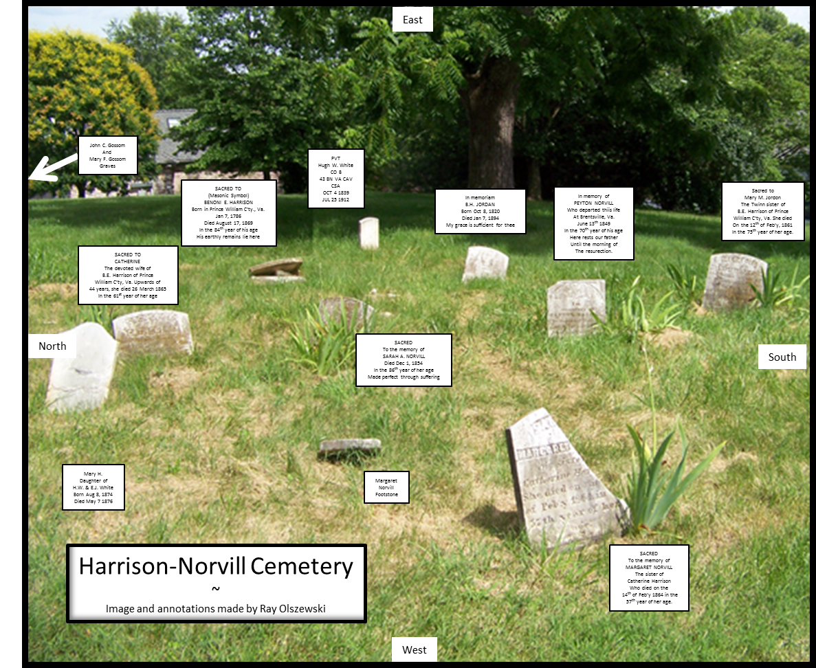
In 2006, 2011, and in 2013 the author made personal visits to the Harrison-Norvill Cemetery. For the most part, things did not change much other than the noted continued deterioration of the tombstones, an increase in the depressions of the earth, and the increased presence of gopher holes. Also noted by the author is that footstones that were previously found were missing. These markers could have been removed purposely or just sank further into the ground and are now covered over with earth or grass growth.
Figure 3. Harrison-Norvill Cemetery August 2011. Photo taken by author.
The white picket fence that once surrounded the two graves of Mary F. and John Cornelius Gossom was removed sometime between 2011 and 2013. A descendant of the Gossom family, Mrs. Peggy Gardner, revealed that as a young child she would visit the Harrison-Norvill Cemetery with her grandfather, George Alton “Allie” Gossom (1878-1977), who reportedly lived at La Grange and who maintained the cemetery. Ms. Gardner said in the phone interview with the author that she does not visit the cemetery now that it is located on private property. As for its deteriorating condition, Mrs. Gardner attributes the condition of the tombstones to have been caused by farm animals or people who may have purposely knocked over the tombstones. She also corroborated that the reason the graves have become depressed was because of the gophers.
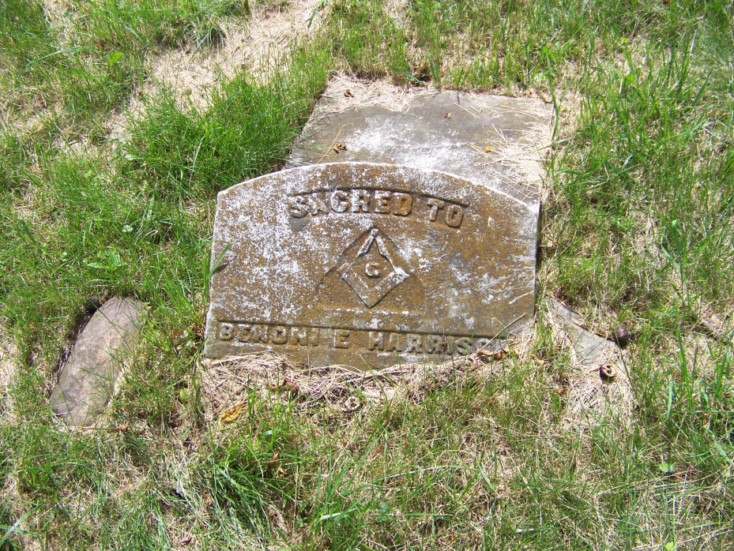
This continued deterioration of the graves and their markers should be of grave concern. The Harrison-Norvill Cemetery is a reverent place and is very historic. The gravestone of Benoni E. Harrison, the benefactor of the Harrison-Norvill Cemetery is in the worse condition of them all. His tombstone shown in Figure 4 shows it to be lying flat against the earth, broken, as if it had been thrown to where it now lies. This author believes these circumstances to be disgraceful and disrespectful to those who gave so much to the historic growth of Prince William County. Benoni Harrison’s life as a public servant served in many honorable ways over many years for the County. In addition, he was also very successful in private life and gave much to the County and to his relatives and many others. He literally gave everything away he had worked for and asked only that his grave stone be inscribed as he had asked in his will and that it is placed over his “earthly remains,” and not ‘thrown’ to where it now lies.
Figure 4. Photograph of broken tombstone of Benoni E. Harrison taken by author August 2011.
This article is the first in a series of telling the story of La Grange, Benoni E. Harrison and those buried at the Harrison-Norvill Cemetery. It is also an example of: how to build on the information that the Commission published in 2001; an example of how the extensive resources found in the County’s library system can be used to find their family’s historical past; bring attention to the rich historical value of these “old” cemeteries offer in family history research and history. And more importantly a historic account of their lives honors, respects, and memorializes those who are buried at the Harrison-Norvill Cemetery; and, brings awareness to the continuing deterioration found today in historic cemeteries throughout Prince William County and in hope that these situations will be remedied.
This is the beginning of my story about the wonderful place called La Grange and the people who once lived there. Profound appreciation goes to all of the original investors who turned the Winery at La Grange into such a wonderful place while resurrecting La Grange’s presence back into the county’s rich history. Let’s now do something for those who once lived there. My profound appreciation goes to Nancy Ingerson, Leslie Joyce White King, Fletcher Henderson, and Don Wilson for their assistance in the many constructive reviews and edits they performed and support they provided for this article; and, hopefully more articles to come. Comments/Questions about the contents of this article are welcome and can be sent to: ROlszewski@aol.com.
The images found below in Figure 5 and 6 are earlier photographs of the Harrison-Norvill Cemetery that were provided as a courtesy of Leslie Joyce White King.
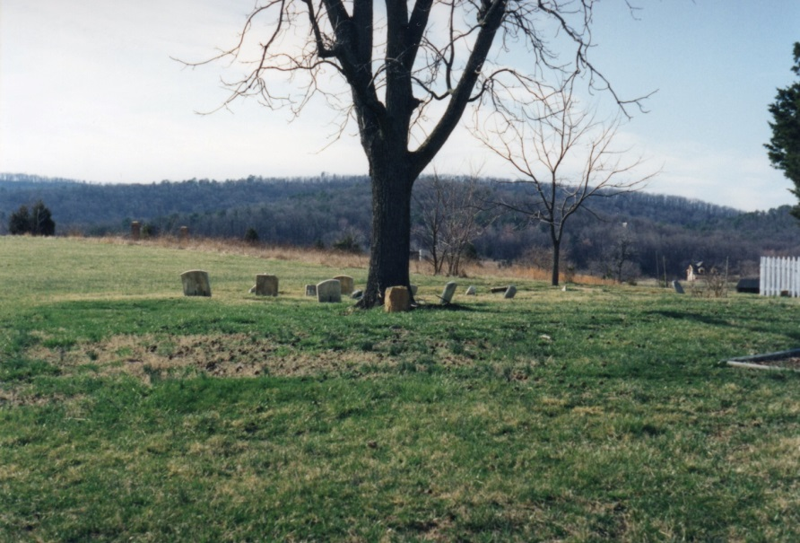
Figure 5. Image of The Harrison-Norvill Cemetery looking westerly.
The Bull Run Mountain range can be seen in the background.
Photo was taken about 1995 and shows the white picket fenced in
Gossom graves. Photo is the courtesy of Leslie Joyce White King.

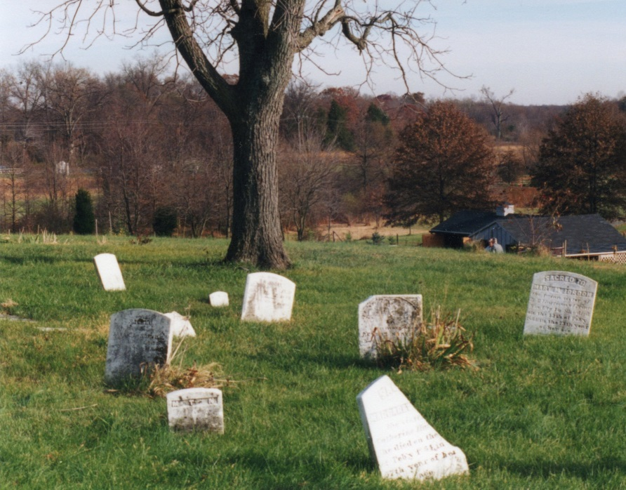
Figure 6. Image shown is of the Harrison-Norvill Cemetery in 1998 looking in an easterly direction. Photo is the courtesy of Leslie Joyce White King.

Ray Olszewski has been a long-time contributor of Reliquary articles. In 2011, Ray researched and published his findings in “A Taste of Prince William County, Virginia Wine History” which expanded on his earlier reliquary article work. Ray was also one of the original investors in the Winery at La Grange and voluntarily became the winery’s historian focusing on the history of the place.
These epitaphs are quoted as they were found in the Prince William County Historical Commission survey conducted by Ronald Ray Turner and Betty Duley in 1997
The use of the term ‘gravestone’ throughout this article is synonymous with tombstone, grave marker, and headstone.
http://www.pwcvabooks.com/Cemeteries1.htm accessed 4/11/2014
The latest Prince William County 2008 Comprehensive Plan High Sensitivity Areas and County Registered Historic Sites, published March 11, 2009 can be found online at the following URL: http://eservice.pwcgov.org/planning/documents/MAP_10W8_2008CP_HiSens_and_CRHS3000.pdf
http://eservice.pwcgov.org/planning/documents/6_cultural_resources.pdf
http://lva1.hosted.exlibrisgroup.com/F/FQH91EBJS3331LL4NQKCKRHY751U669ITTUCX81V3V9Y4NPC5F-15686?func=full-set-set&set_number=002466&set_entry=000008&format=999
Research found the family name of Jordan to have many and varied spellings to include: Jourdin, Jourden, Jourdan, Jordan, and Jordon.
http://www.pwcvirginia.com/Cemeteries1.htm accessed 3/27/2014
Benoni E. Harrison Last Will and Testament found in Prince William County Will Book R, pages 546-548, transcribed by Ray Olszewski, April 27, 2006 and on display at the Winery at La Grange
Benoni E. Harrison Last Will and Testament found in Prince William County Will Book R, pages 546-548, transcribed by Ray Olszewski, April 27, 2006 and on display at the Winery at La Grange
Index to Death Records of Prince William County Virginia – ABSTRACTED RELIC Bull Run Regional Library, Manassas, VA, page 119
A Biography of Ms. Morton can be found at Prince William Reliquary Vol. 8, No. 3 (July 2009) titled Susan Rogers Morton, pages 62 and 63
The purpose of the WPA effort was to give work to the unemployed during the depression. After World War II began, the program was terminated in 1942.
WPA Records of Prince William County, Virginia by W. R. Hobbs, Teresa A. Kelley, and Sallie C. Pusey, published by Willow Bend Books, Westminster, MD 2001, pages 312-315
Ibid, p. 313
Ibid, p. 313, 314
Ibid, p. 314
Ibid, p. 314
Benoni E. Harrison Last Will and Testament found in Prince William County Will Book R, pages 546-548, transcribed by Ray Olszewski, April 27, 2006 and on display at the Winery at La Grange
Beatrice White, The Descendants of Wesley Willis White (1812-1886), compilation, 1995, pages, 3-5.
Sources include Peyton Norvill’s Tombstone found at the Harrison-Norvill Cemetery and Peyton Norvill’s will he wrote at Sudley, March 24th 1842 found at Prince William County Court Archives Will Book “Q”, page 418
Virginia Historic Landmarks Commission Survey Form of La Grange, File no. 76-12 date of record Aug 5, 1959
Ibid
ibid
E.R. Conner, III, 100 Old Cemeteries of Prince William County, Virginia, published 1981, p. 176 of 207 pages.
100 Old Cemeteries of Prince William County, Virginia, VA, page 175, E.R. Conner, published 1981
E.R. Conner undated notes held by RELIC La Grange files
ibid
E.R. Conner III, 100 Old Cemeteries of Prince William County Virginia, published 1981, p. 176
ibid
Benoni E. Harrison Will’s Codicil dated January 23, 1869
E.R. Conner, III, 100 Old Cemeteries of Prince William County, Virginia, published 1981, p. 176 of 207 pages.
E.R. Conner III, 100 Old Cemeteries of Prince William County Virginia, published 1981, p. 176
Family records produced by Beatrice White, The Descendants of Wesley Willis White (1812-1886), compilation, 1995, pages, 3-5.
Prince William County Historical Commission Cemetery Register Form found as Harrison-Norvill.doc1.doc at: http://www.pwcvabooks.com/Cemeteries1.htm
ibid
Benoni E. Harrison Last Will and Testament found in Prince William County Will Book R, pages 546-548, transcribed by Ray Olszewski, April 27, 2006 and on display at the Winery at La Grange
Dick Gossom (1873-1959), Memories of Gossoms Past and Present, and Relative Relatives, obtained and copied held by author, date unknown.
ibid
E.R. Conner, III, 100 Old Cemeteries of Prince William County, Virginia, published 1981, p. 176 of 207 pages
http://www.gravestonestudies.org/faq.htm
Family records produced by Beatrice White, The Descendants of Wesley Willis White (1812-1886), compilation, 1995, pages, 3-5
Prince William County Deaths, 1912-1917, p. 1047
John T. Toler, Discovered History, Part 1: Benoni Harrison’s Plantation Flourished Until the Civil War, Haymarket Lifestyle, page 24
United Daughters of the Confederacy email dated 4/4/2013 from library@hqudc.org to author
Ibid, page 3
Ibid
Interview with Mark Joyner, A.S.A.P. LLC The Association for the Study of Archaeological Properties, Limited Liability Corporation, January 2005
1860 Slave Schedules found on Ancestry.com accessed 1/26/2006

